**Name : Aditya Vinayak Patil**

**Div: SE-A**

**Roll No: 42**

**EXPERIMENT NO.3**

**Q1)**

**ANS]**

i)create table EMP( Emp_no int ,

E_name varchar(20),

E_address varchar(30),

E_ph_no varchar(10),

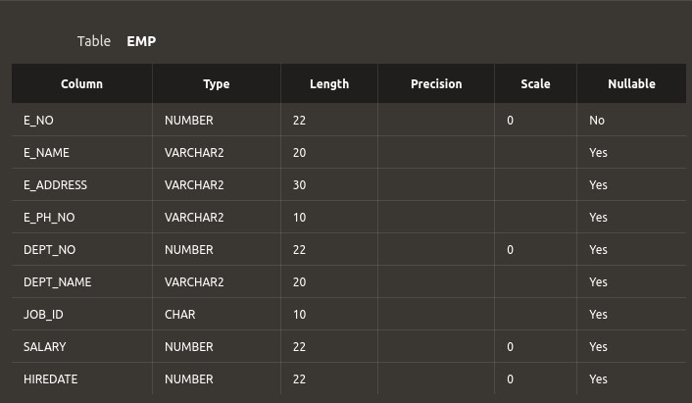Dept_no varchar(10),

Dept_name varchar(20),

Job_id char(10),

Salary int

)

ii)ALTER table EMP Add (HIRE_DATE int); iii)ALTER table EMP Add Unique(Dept_no); iv)ALTER table EMP

RENAME COLUMN Emp_no to E_no; v)ALTER table EMP Add Primary key(E_no);

Q2)

Create Table Dept(

DEPTNO varchar(10),

DNAME varchar(10),

LOC varchar(50),

PRIMARY KEY (DEPTNO)

);

Alter Table Dept

RENAME to Department;

Alter Table Department

Add (PINCODE varchar(10));

ALTER table Department

RENAME COLUMN DNAME to DEPT_NAME;

